Detailed Analysis of Lok Sabha Election 2024

Total Number of Votes by states

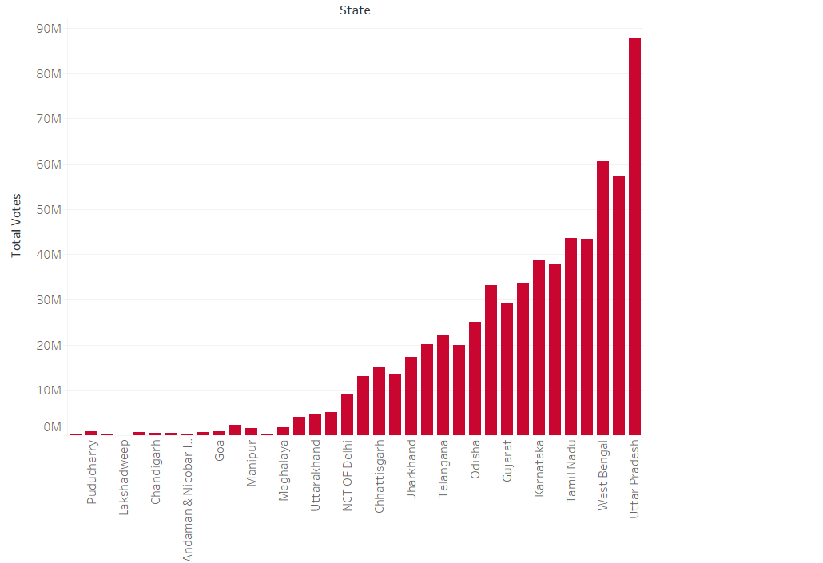

Won and Lost Votes by Party

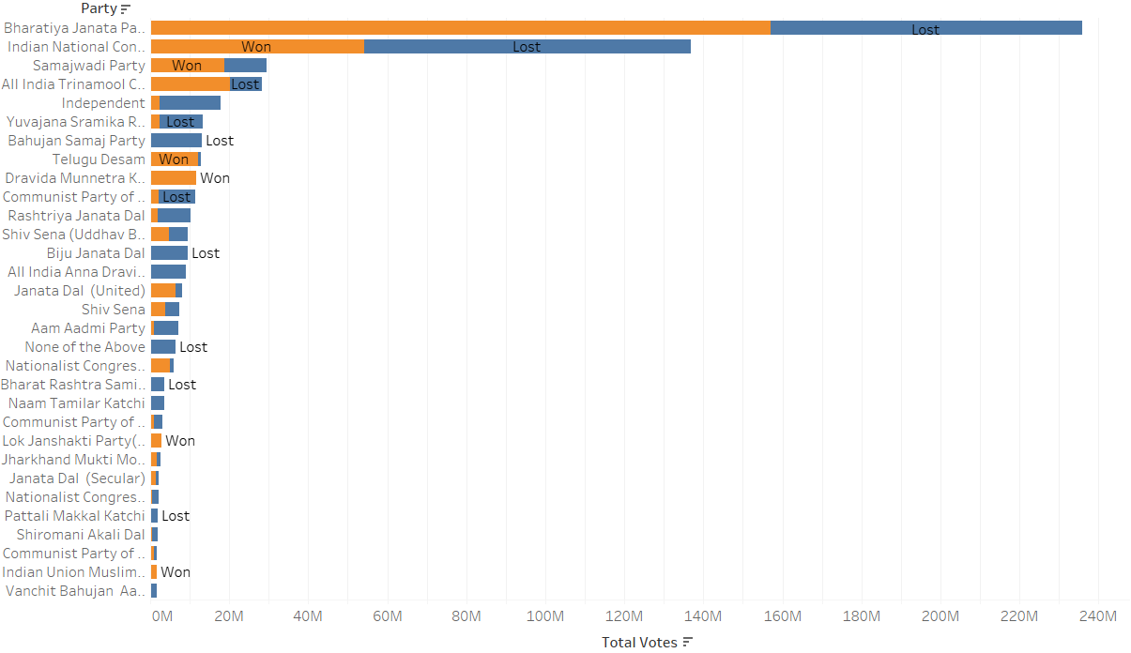

Total Votes by party by states

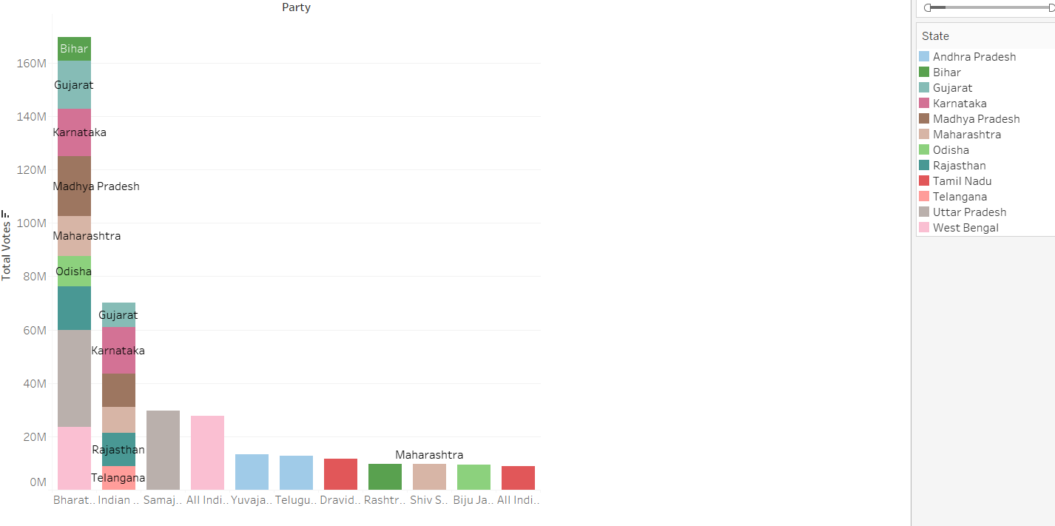

Total Votes by states by party

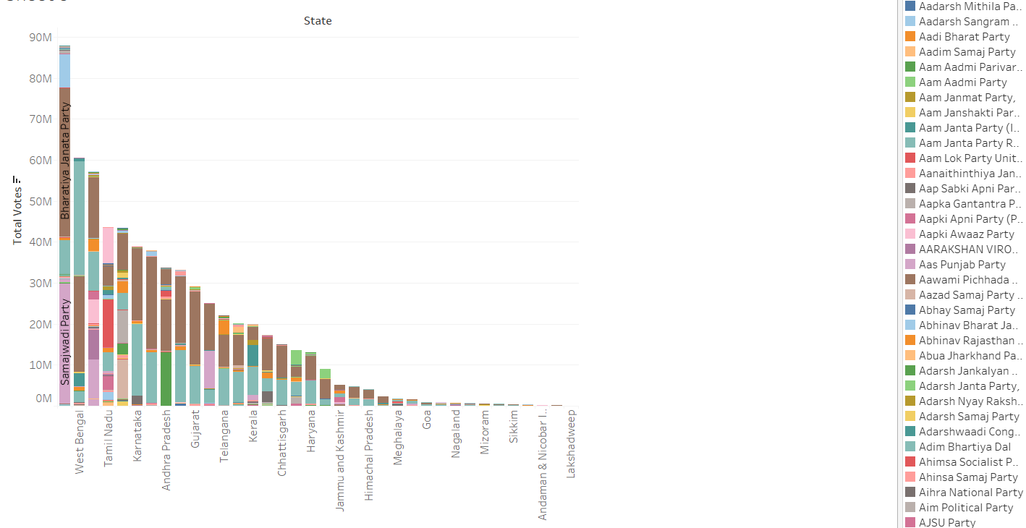

Won and Lost votes by party by states

